## Capstone Project - The Battle of Neighborhoods

## Manhattan Grocery Store Location Suggestion

**Author: Vijay Unnikrishnan**

**Data Section**

* **Data title:**

Coordinates of each NYC Neighborhood

**Type of data:**

JSON

**Description of the data:**

A dataset that contains the New York City’s 5 boroughs and the neighborhoods that exist in each borough as well as the latitude and longitude coordinates of each neighborhood. This dataset exists for free on the web.

**Source:**

<https://geo.nyu.edu/catalog/nyu_2451_34572>

**Data Example:** The latitude and longitude of all the Neighborhoods of Borough Bronx in New York City can be retried from this dataset:

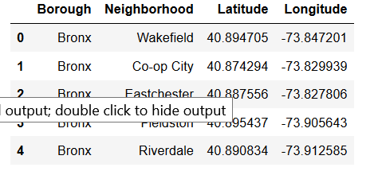

* **Data title:**

Foursquare location data

**Type of data:**

JSON

**Description of the data:**

Location coordinates obtained by Foursquare API calls.

To determine the proximity of various amenities as per the client’s requirement, Foursquare location data is used.

**Source:**

<https://foursquare.com/>

**Data Example:** Using Foursquare API calls we extract features of the nearby venues, viz. venue names, venue categories and venue coordinates (latitude, longitude):

